**Practical No. 9: Write a program to launch a JProgressBar.**

**Program Code:**

1. **Write a program code to generate the following output.**

**Program:**

import java.awt.*;

import javax.swing.*;

import java.applet.*;

public class pract9_X1 extends JApplet

{public void init()

    {Container c = getContentPane();

        c.setLayout(new FlowLayout());

        JProgressBar jp = new JProgressBar(0,100);

        jp.setValue(100);

        jp.setStringPainted(true);

        c.add(jp);

    }}

/* <applet code=pract9_X1  width=500 height=500></applet> */

**Output:**

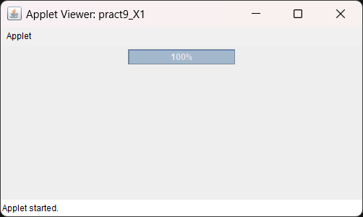

**Exercise:**

1. **Develop a program to demonstrate the use of JProgressBar.**

**Program:**

import java.awt.*;

import javax.swing.*;

import java.awt.event.*;

public class pract9_ex1 extends JApplet

{public void init()

    {

        Container c = getContentPane();

        c.setLayout(new FlowLayout());

        JProgressBar jp = new JProgressBar(0,100);

        jp.setValue(66);

        jp.setStringPainted(true);

        c.add(jp);

    }

}

/* <applet code=pract9_ex1  width=500 height=500></applet> */

**Output:**

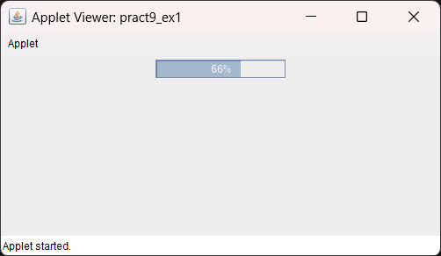

1. **Write a program using JProgessBar to show the progress of Progressbar when user clicks on JButton.**

**Program:**

import java.awt.*;

import javax.swing.*;

import java.awt.event.*;

public class  pract9_ex2 extends JFrame implements ActionListener

{

    JButton b = new JButton("Submit");

    JProgressBar jp = new JProgressBar(SwingConstants.HORIZONTAL , 0 ,100);

    pract9_ex2()

    {setVisible(true);

        setSize(500,500);

        setLayout(new FlowLayout());

        setDefaultCloseOperation(JFrame.EXIT_ON_CLOSE);

        jp.setValue(0);

        jp.setStringPainted(true);

        add(jp);

        add(b);

        b.addActionListener(this);

    }

    public void actionPerformed(ActionEvent e)

    {if(e.getSource() == b)

        {int i =10;

while(i<=100){

                        jp.setValue(i);

                       try

                       {Thread.sleep(1000);

                       } catch (Exception ex) {

                   }

i = i + 10;

                    }    }

    }

    public static void main(String[] args) {

        new pract9_ex2();

    }}

**Output:**

